**NABBUNGA FOUNTAIN OF EDUCATION DAY AND BOARDING PRIMARY SCHOOL,**

**DEZ JUNIOR SCHOOL, ST. MARY’S IMMACULATE VILLA P/S, ST. THEREZA BWANDA P/S, ACT JUNIOR SCHOOL,**

**ST. ANDREWS MATALE HILL P/S, AND**

**ST. AGNES NSAMBYA PRIMARY SCHOOL**

**PRE-P.L.E JOINT EXAMINATION 2022**

# 

# SUBJECT : MATHEMATICS

# DURATION : 2 HOURS 30 MINUTES

**EMIS NO.**

**PERSONAL NO.**

**Index No. :**

**Candidate’s Name : …...…………………………….…………………..............**

**Candidate’s Signature : …...…………………………………….………............**

**District Name : …..……………………..……………….……...................**

***DO NOT OPEN THIS BOOKLET UNTIL YOU ARE TOLD TO DO SO.***

**SECTION MARKS**

**A**

**B**

**FOR EXAMINER’S USE ONLY**

**TOTAL MARKS**

**Read the following instructions carefully:**

1. This paper has **two** sections: **A** and **B**.
2. All the working for both sections **A** and **B**

must be shown in the spaces provided.

1. All working must be done using a blue or black ball-point

pen or fountain pen. Any work done in pencil other than

graphs, pictures and diagrams will **not** be marked.

1. **No calculators** are allowed in the examination room.
2. Unnecessary changes of work may lead to **loss** of marks.
3. Any handwriting that cannot easily be read may lead to **loss of marks.**
4. Do **not** fill anything in the boxes indicated: **“For Examiners’ Use Only”**

**SECTION A (40marks);**

**Questions 1 to 20 carry two marks each**

1. Multiply 2 0 3

X 2

____

1. Write in figures: forty six thousand nine.
2. In the Venn diagram below, find the number of elements in set P.

**P Q**

3 1 5

4 2 7 6

8

1. Find the sum of the next numbers in the sequence

1, 4, 9, 16, ____, ____

1. Work out -2 + +9
2. With a help of a ruler, a pencil, and a pair of compasses only, construct an angle of 600 in the space below.
3. Find Lowest Common Multiple (L.C.M) of 12 and 8.
4. Find the median of 2, 3, 3, 6, 4
5. Add: 31five + 44five
6. Increase shs. 1,200 in a ratio4:3
7. A forty minute lesson started at 11:00a.m. When did it end?
8. A kite has an area of 120cm2. If one of its diagonals is 8cm, find the length of the second diagonal.
9. Musa deposited shs. 80,000 in a bank at a simple interest rate of 2% per month for 2yrs. Find the interest earned after 2 years.
10. Solve the inequality:

4n – 7 6n + 11

1. Four mangoes cost sh. 800. What is the cost of 12 similar mangoes?
2. The bearing of Ssembabule town from Kyotera is 0700. What is the bearing of Kyotera from Ssembabule town?
3. Find the value of .

0

600



1. Given that represents 20 balls and represents 24 cups. Find



the total number represented by , , .

1. After covering a distance of 40km, Mary still had ¾ to cover. How long was the whole journey?
2. The market price on 1kg of sugar is sh. p. John bought 3kg of sugar at the marked price, but Joanah bought 7kgs at a 50% discount on the market price. Find p if they paid sh. 32500/=

**SECTION B**

1. The table below shows MARKS SCORED BY PUPILS in P.6. Use it to answer questions that follow.

|  |  |  |  |  |  |
| --- | --- | --- | --- | --- | --- |
| Marks obtained | 30 | 50 | X | 22 | 61 |
| Number of pupils | 2 | 3 | $$2$$ | 1 | 2 |

1. How many pupils did the test? (1mark)
2. Find modal mark. (1mark)
3. Calculate the value of $x$ if the mean mark is 51. (3marks)
4. a) Find the sum of the value of 7 and value of 3 in 7432. (3marks)

b) Change 101two to decimal base. (2marks)

1. Tap A takes 3 hours to fill the tank and tap B takes 4 hours to draw water from the tank. How many hours will it take to fill the tank if both taps are left open? (5marks)
2. The Venn diagram below shows number of pupils who like Posho (P) and rice (R). Use it to answer the questions that follow. If n(P) = 16

n(P) n(R)

2x - 4 x + 2 6x

1. Find the value of x. (2marks)
2. Find the number of pupils who like one type 0f food. (2marks)
3. Find the probability of picking a pupil who like both posho and rice.

(1mark)

1. A bag of sugar weighing 50kgs, costs sh. 250,000/=.
2. What is the cost of each kilo? (1mark)
3. If a shopkeeper sold each kg of sugar at shs. 6,000, how much money did he collect from a 50kg bag of sugar? (2marks)
4. Calculate the profit gained after selling a 50kg bag of sugar at sh. 3,000 per half kg. (3marks)
5. Using a ruler, a sharp pencil and a pair of compasses only, construct a triangle KLM in which KL = 7cm, angle KLM = 750 and LKM = 450.

(4marks)

b) Drop a perpendicular from M to meet KL at D. (1mark)

1. Peter, Rose, Sarah and Musa shared money in a ratio 2:3:4:5. If Rose got shs. 1500;
2. How much money was shared altogether? (2marks)
3. How much money did Musa get more than Rose? (3marks)
4. The interior angle of a regular polygon is 1200 more than its exterior angle.
5. Find the exterior angle. (3marks)
6. Name the polygon. (2marks)
7. A potter poured water in container A using a cup of size B. Use the diagram below to answer the questions that follow.



50cm

30cm 14cm

60cm

1. Find the volume of the cup B. (2marks)
2. How many cupfuls of size B did he pair into container A to fill it?

(3marks)

1. a) Workout: 0.72 x 0.08 (2marks)

0.9 x 0.4

b) Change 0.2727…… as a common fraction. (2marks)

1. The sum of 4 consecutive even numbers is 52.
2. Find the numbers. (3marks)
3. Calculate their range. (1mark)
4. A motorist left Kampala at 7:00a.m and covered 50km to Lugazi in 1½ hours. He rested for 30 minutes and then continued to Jinja where he arrived at 10.00a.m.
5. How the motorist’s journey on the graph bellow. (3marks)

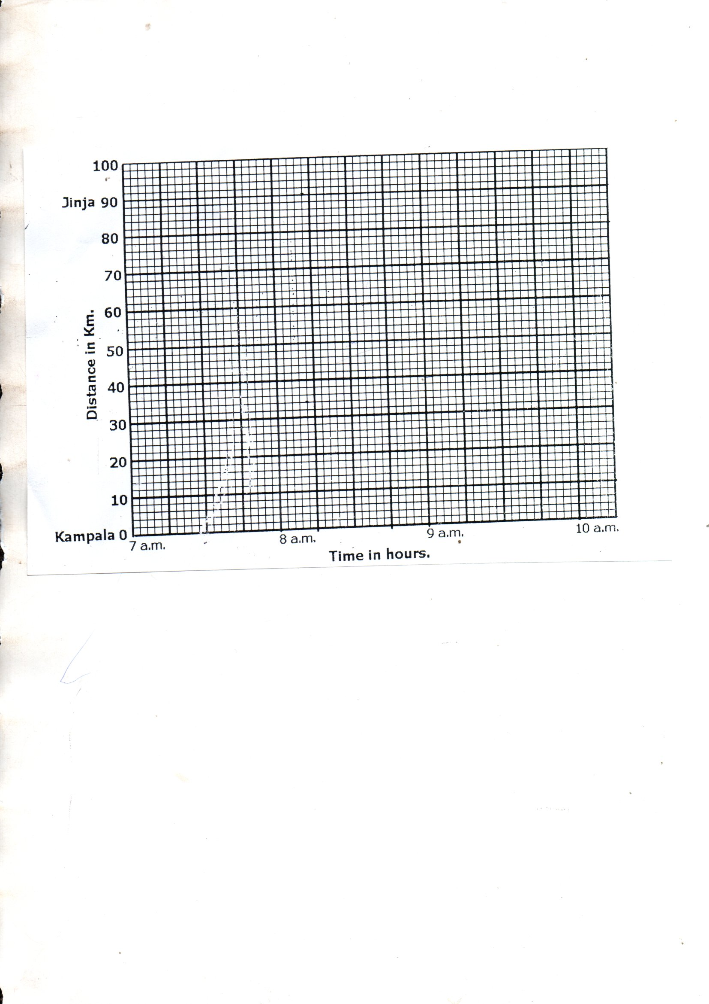

1. Lugazi is 50km from Kampala. Indicate Lugazi on the graph. (1mark)
2. What is the average speed of the motorist for the whole journey?

(2marks)

**\*\*\*GOD FEARING IS THE SOURCE OF WISDOM\*\*\***